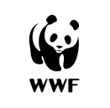
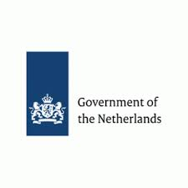

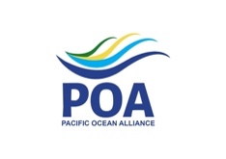
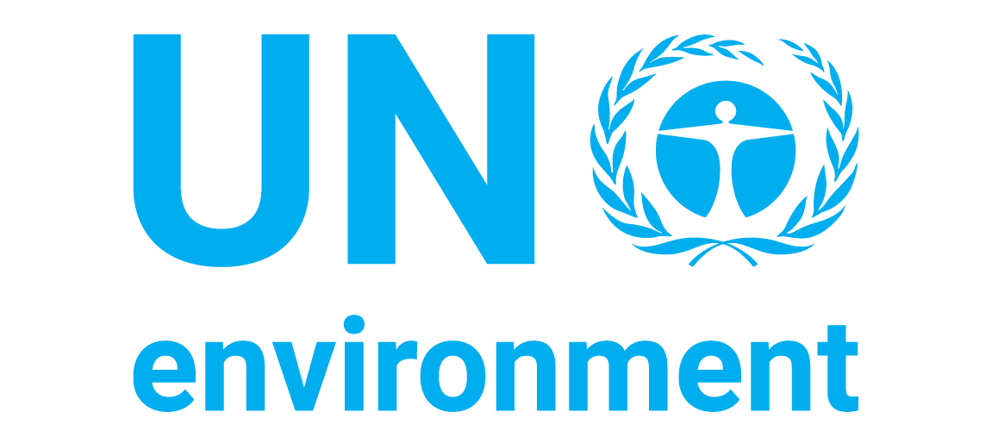
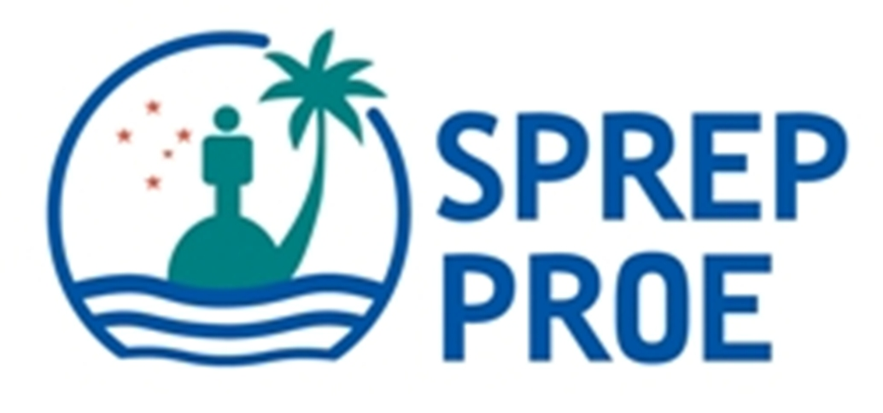

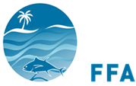
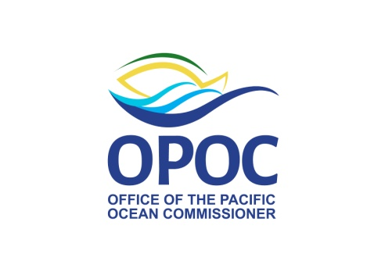
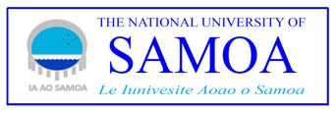

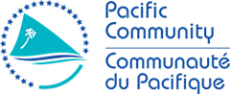
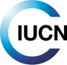
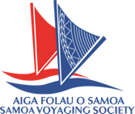
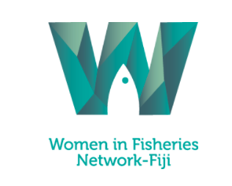
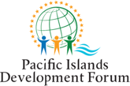





Media tip sheet: Women as ocean leaders

Thank you for considering this topic and our actions for your writing! This document contains details of our event at the United Nations Ocean Conference (5–9 June 2017), speakers, and partners as well as key facts to pique your interest and give you options for follow-up interviews or research.

Event title: Healers of our Ocean: Asia-Pacific women leading ocean action to achieve SDG14
Date: Monday, 5 June 2017
Time: 15:00 to 16:30
Location: UN Headquarters, New York, NY, USA, Conference Room 12
Event Contacts:
Dr Tiffany Straza, UN Environment consultant, tstraza@gmail.com Tel. +685 720 9604 (Samoa) or 1-306-371-4284
Mr Alfred Ralifo, WWF Policy Coordinator, aralifo@wwfpacific.org Tel. +679 331 5533 (Extension: 131)
Website: More information and news at the Pacific Voyage to the UN Ocean Conference site: https://www.sprep.org/pacific-voyage-un-ocean-conference-2017/ocean-healers

Profiles and for more information:
Profiles of Asia-Pacific women ocean leaders can be found on http://bit.ly/2qaceHB

Why this event?
Women at all levels contribute to ocean leadership, management and use, conservation and science. SDG14 needs women.

We hope to inspire more women to become marine specialists by celebrating women’s successes in ocean leadership. We want to generate action to support women in marine leadership and management by identifying gaps or barriers, and solutions, focusing on women and girls in the developing world. We seek commitment to include women in integrated ocean management planning, using best-practice strategies in acknowledgement of diverse and unique cultures.

What can people do to help?
- Build gender inclusivity and equality into their work in the Asia-Pacific region during project planning and community development
- Invest in basic science, engineering, technology and mathematics education for girls and women in the developing Asia-Pacific region
- Support the inclusion of women and minorities in social, professional and political roles at all levels
- Listen to the voices of Asia-Pacific women to understand their values and needs. You can start with the profiles on this page: bit.ly/2qaceHB

Why share stories?
Again and again, we see that young women and girls choose career paths only after seeing someone they identify with succeeding in that career, and this visualisation is especially critical for STEM and technical careers.

Awareness can lead to inclusion. By seeing how women connect with the ocean, we can identify ways to nurture those connections. We can identify strategies to incorporate women’s views and knowledge in ocean management. Ocean management without women will not work.

Women must be included for effective integrated ocean management.

Our media campaign goal:
Increase the visibility of Asia-Pacific female ocean leaders to equip more young women to choose these career paths and to demonstrate to development partners the need to include women's opinions and ocean uses in integrated ocean management decisions.

Follow along on #MoanaVoices, #SaveOurOcean and #Ocean4People

Event speakers:
- Karolina Skog, Minister for the Environment
  - Karolina Skog has been Minister for the Environment since May 2016, responsible for environmental issues, urban environment agreements and urban development. She is a member of the Green Party and served as City Commissioner in Malmö Municipality from 2010 until being appointed cabinet minister. Ms. Skog holds a Master in Human Ecology from Lund University.
- Dame Meg Taylor, Pacific Ocean Commissioner and Secretary General of the Pacific Islands Forum
  - Dame Meg Taylor is a national of Papua New Guinea. She studied at the University of Papua New Guinea, and received her LL. B from Melbourne University, Australia, and her LL.M from Harvard University, USA. She practiced law with the Office of the Public Solicitor and in the private sector, and served as a member of the Law Reform Commission. She was Ambassador of Papua New Guinea to the United States, Mexico and Canada in Washington, DC from 1989–1994. In 2002, she was made a Dame Commander of the Order of the British Empire. Dame Taylor was appointed to the post of Vice President and Compliance Advisor Ombudsman (CAO) of the World Bank Group in 1999. She has also served on the boards of international conservation and research organizations as well as companies. In August 2014, Dame Meg was appointed by Pacific Islands Forum Leaders as Secretary General of the Pacific Islands Forum, a political grouping of 16 independent and self-governing states.
  - Alternate speaker: Ms. Cristelle Pratt is the Deputy Secretary General of the Pacific Islands Forum, a political grouping of 16 independent and self-governing states. She has tertiary qualifications in marine geoscience and marine law and policy, having read at universities in Australia and Canada. She has worked in the public and private sectors, including holding the role of Director of the Pacific Islands Applied Geosciences Commission (now a substantive division of the Pacific Community [SPC]). Her interest in ocean governance and risk governance has resulted in a longstanding commitment to developing regional policies, that include the Framework for a Pacific Oceanscape endorsed by the Pacific Forum Leaders in 2010 and the Framework for Resilient Development in the Pacific, endorsed by Leaders in 2016.
- Ms. Tarusila Veibi, Fiji Locally Managed Marine Area (FLMMA) Network
  - Tarusila Veibi Ratu hails from Lomanikoro village, District of Bua in the Province of Bua. She has been a Conservationist with the Fiji Locally Managed Marine Area (FLMMA) Network since 2008. She is also a committee member of the Bua Yaubula Management Support Team, established in 2010, and is the only woman representing a Tikina (District) at the BYMST meetings. She continues to play an integral position in her advisory role to the leaders within her province on matters concerning natural resource management.
- Ms. Rindah Melsen, President of Nusatuva Women’s Saving Club, Solomon Islands
  - Ms. Rinda Melsen is the President of the Nusatuva Women’s Savings Club. Rinda says the initiative has been an empowering one for women in her community. The means to generate income from the micro-businesses has enabled them to secure necessities for their households and pay for their children’s school fees. The Nusatuva Womens Savings Club was initiated in 2014 by WWF to encourage savings and generate a funding pool for small-scale business development with women. What started off with SB$20 with 5 women in 2014 has now reached a savings of SB$25,000.30 with 64 members as women in the community began to see the benefit of being part of the initiative. Ten loans have been issued by the Savings Club to establish businesses. From the profits generated, one of the women has built herself a new home. Previously, the Nusatuva Environment Conservation Development Association (NECDA) which coordinates development in the community was male-dominated. The success of the Savings Club has also brought recognition from the men, who now involve the women more in decision-making processes. The women have even been asked to set up a similar savings club for the men, but for now, their primary focus is women.
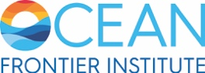
- Dr. Wendy Watson-Wright, Chief Executive Officer of the Ocean Frontier Institute
  - Dr. Wendy Watson-Wright is the Chief Executive Officer of the Ocean Frontier Institute (OFI), the new Canadian-led interdisciplinary transnational research institute whose aim is the safe and sustainable development of the ocean frontier.
  - Dr. Watson-Wright was the first woman to be appointed as Executive Secretary and Assistant Director General of the Intergovernmental Oceanographic Commission of UNESCO (IOC-UNESCO) in Paris. For most of her career, she held various senior positions within Fisheries and Oceans Canada, including as the first female Assistant Deputy Minister of Science.
  - Dr. Watson-Wright has been on several boards and panels including the Strategic Advisory Board for the European Union’s Joint Programming Initiative on Oceans (JPI Oceans), the Council of Canadian Academies’ Expert Panel on Ocean Science, and the Scientific Advisory Board of the Wendy Schmidt Ocean Health X-Prize. A Killam scholar, she holds a Ph.D. in Physiology from Dalhousie University in Halifax, Nova Scotia.

Key facts about women and ocean management:
At the academic level, statistics show in the last five years, women represented over 50 per cent of the graduates, both Bachelors and Masters Degrees, from the University of the South Pacific's Marine Science Programmes.
Despite the growing number of women enrolling in marine science university programmes, women accounted for only 18% of fishery science and management staff in Pacific islands according to a 2011 study. In contrast, women accounted for more than 60% of administrative and clerical staff in government fisheries divisions.
Women use and hold important knowledge of many marine resources and spaces, but including women's voices in governance decisions requires key strategies acknowledging the social and cultural traditions in the Pacific.

Event Partners (alphabetical):
Government of the Netherlands

Fiji Locally Managed Marine Areas (FLMMA) Network develops community-driven management for the health and continued production of coastal fisheries, essential for Fijian livelihoods. The inclusion of women is integral to gain both community consensus and local knowledge for effective, sustainable management mechanisms.
International Union for the Conservation of Nature (IUCN) considers gender equality and equity are matters of fundamental human rights and social justice, as well as a pre-condition for sustainable development. IUCN is committed to furthering gender equality and equity in order to build a Union that understands the importance of equal opportunity and inclusion, and whose policies respect diversity.
National University of Samoa – Faculty of Science has a new marine studies programme and seeks to equip students with the training they need for a variety of marine-related careers.

Office of the Pacific Ocean Commissioner (OPOC) & Pacific Islands Forum Secretariat supports gender equality integration within key regional policy initiatives and decisions by leaders. The Pacific Leaders Gender Equality Declaration is a regional political instrument that guides actions within the Forum countries in six key areas: gender responsive government policies and programmes, decision making, women’s economic empowerment, ending violence against women, education and health. PIFS provides oversight and monitoring on gender equality commitments made by leaders and provides advice, regional and global level advocacy and facilitates partnerships to accelerate gender equality work in the region. The key focus of the Secretariat’s policy advice and services in the region has been on improving women’s leadership in parliament, state owned boards and women’s economic empowerment and sexual gender based violence. The development of regional public policies that consider gender equality issues is progressing through the Framework for Pacific Regionalism.

Okeanos Foundation for the Sea is a philanthropic organization committed to helping the Pacific islands become economically resilient, while preserving cultural practice and knowledge, by providing traditionally designed sailing canoes equipped with modern technologies (solar panels and coconut oil engines). For more than eight years, Okeanos has been committed to training women sailors, skippers and navigators. Okeanos sailing canoes are internationally certified for open ocean commercial use and used for cargo and passenger transport, disaster relief, scientific research, ecotourism and education.

The Pacific Community (SPC) supports women’s empowerment through fisheries activities and the promotion of cultural industries with the objective that women gain a fair return from their crafts and work. SPC works alongside the Pacific islands countries to make sure policies, programmes and practices are fair and support equality between women and men and empower women. Such policies ensure that women, who depend on the rich ocean’s resources for their livelihood, benefit equitably from the protection and sustainable use of marine resources.

Pacific Island Development Forum (PIDF) has the mission of a united, distinctive and sustainable Pacific society. PIDF serves its 13 Member countries by enabling Blue-Green Pacific economies through inclusive strategies, multi-stakeholder governance, and genuine partnerships. PIDF seeks to accelerate the integration of the three pillars of sustainable development (environment, social, and economic) to balance the pursuit of economic growth against the needs of societies and the sustainability of the environment; and to foster an inclusive change agenda that address the root causes of unsustainable development practices.

Pacific Islands Forum Fisheries Agency (FFA) - Oceanic Fisheries Management Project. FFA strengthens national capacity and regional solidarity so its 17 members can manage, control and develop their tuna fisheries now and in the future. In July 2016, fisheries ministers unanimously endorsed FFA’s Gender Equity Framework to underpin our work in this key area. Since that time, we have secured funding from the Government of Sweden to begin the design and planning stages of a broad-based gender program for the Agency, industry and members.

Samoa Voyaging Society – Aiga Folau o Samoa (SVS) was established in 2009 when the people of Samoa received Gaualofa from Okeanos – Foundation for the Sea, which remains a significant partner of SVS. Gaualofa is a 22 metre long double-hulled voyaging canoe built in the traditional shape but out of modern materials. SVS’s main goals are to promote the revival of Samoan cultural traditions related to ocean sailing and navigation and the wise stewardship of the Pacific encouraging conservation, protection, awareness and preservation of the Pacific Ocean and island environments.

The Secretariat of the Pacific Regional Environment Programme (SPREP) is an intergovernmental agency mandated by its 26 Member countries for regional environmental management. SPREP works to promote inclusive environmental management, as one of the agencies in the Council of Regional Organisations of the Pacific. Regional resources are available to support development partners in these efforts, such as the Pacific Gender & Climate Change Toolkit.

The Nature Conservancy (TNC) recognises that taking gender into account is critical for effective conservation, and is working to advance women’s empowerment through projects and programs across the globe. For example, in the Solomon Islands, we are collaborating with the Isabel Mothers’ Union to involve women in decision-making for natural resource use, work which has reached over 12,000 people in remote communities and allowed women to influence national mining policy reform process. In Australia, we are working with women’s ranger groups to expand the pool of women involved in land management and to facilitate knowledge transfer between women elders and younger women and girls. We also co-founded the Women Leaders Forum of the Coral Triangle Initiative to promote and connect women leaders across the region. As an organisation, we are building partnerships and conducting research to demonstrate the benefits of engaging women, have integrated gender guidance into our guiding framework for conservation globally, and are also proud to support a Women In Nature Steering Committee to leverage the full potential of women working at TNC in both conservation and leadership roles.

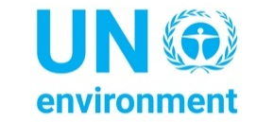
UN Environment Programme promotes the coherent implementation of the environmental dimension of sustainable development within the United Nations system and serves as an authoritative advocate for the global environment. UN Environment recognizes gender as a cross-cutting priority and is working to promote the importance of women´s participation in achieving sustainable development. UN Environment demonstrates an understanding of gender dynamics and differentiation in each region, country, and context where interventions are implemented.

UN Entity for Gender Equality and the Empowerment of Women (UN Women) is the global champion for gender equality, working to develop and uphold standards and create an environment in which every woman and girl can exercise her human rights and live up to her full potential. Grounded in the vision of equality enshrined in the UN Charter, UN Women, among other issues, works for the elimination of discrimination against women and girls; empowerment of women; and achievement of equality between women and men as partners and beneficiaries of development, human rights, humanitarian action and peace and security.

UN Food and Agriculture Organization (FAO) of the United Nations is working with its partners to support the empowerment of women in fisheries (see also http://www.fao.org/fishery/topic/16605/en), including through the implementation of the Voluntary Guidelines for Securing Sustainable Small-Scale Fisheries in the Context of Food Security and Poverty Eradication, which contain a specific chapter on gender equity (see www.fao.org/3/a-i4356e.pdf).

The Wildlife Conservation Society (WCS) launched a 5 year program in 2015 to raise the profile of women in the fisheries sector in Fiji. WCS is currently working with women fishers that target mud crabs to help them protect their mangroves, develop management plan for their fisheries, and improve and diversify their access to markets.

Women in Fisheries Network – Fiji mission is to facilitate networks and partnerships to enable opportunities for women to be informed about all aspects of sustainable fisheries in Fiji and to increase the meaningful participation of women in decision-making and management at all levels of sustainable fisheries in Fiji. WIFN-Fiji works in partnership with other NGOs, Government ministries, national and regional agencies in deciding, designing and delivering activities.

World Wildlife Fund (WWF) is working with other NGO partners to launch a new website, Ocean Witness, to capture, highlight and showcase inspiring women ocean champions from around the world and the significant role they play in sustainable management and development of our marine resources for people and the planet.

For more about SDG14 and the UN Ocean Conference, please visit: https://oceanconference.un.org/

